**ContractFlow: Simplifying Contract Management**

A Web Proposal

Presented to

The Faculty of

College of Information and Communication Technology

South East Asian Institute of Technology, Inc.

In Partial Fulfillment

of the Requirement for the Subject

IT ELEC 3: Web System & Technologies

**PROPONENTS NAME**

DELGADO, KEYAN ANDY

OGATIS, JENER KEVIN

MAROT, ABDUL AZIS

LAURA, MACALANDA

**PROJECT BACKGROUND**

In the contemporary business landscape, contracts serve as the foundation for most transactions and agreements. Effective contract management is vital for organizations to ensure compliance, mitigate risks, and optimize their operations. The ContractFlow system represents a cutting-edge software solution designed to tackle the challenges associated with contract management, offering a comprehensive suite of tools for creating, tracking, and managing contracts in the context of project management. It is worth noting that ContractFlow has been developed using a powerful combination of tools and programming languages, with PHP for server-side scripting and SQL for database management. This technical foundation has given rise to a robust and efficient system that not only simplifies contract management but also facilitates real-time project progress monitoring, automated contract execution, and immutable record-keeping (Gai, K., Qiu, M., & Liu, Z., 2018).

A pressing concern in modern contract management is the heightened risk stemming from mismanagement. Ineffective tracking and monitoring of contracts can result in missed deadlines, overlooked obligations, and non-compliance with legal and regulatory mandates. These issues may lead to costly legal disputes, financial penalties, and reputational damage, all of which pose substantial threats to an organization's sustainability and growth. Furthermore, compounding this risk is the continued reliance on manual and paper-based contract management practices, which prove highly inefficient and susceptible to human error. These outdated methods not only consume valuable time but also drain productivity, contributing to a decline in overall operational efficiency. This situation is untenable in an era where businesses are perpetually pursuing process optimization to stay competitive (Smith, J., 2020).

To fully harness the potential of ContractFlow in addressing the pressing challenges of contemporary contract management, we propose several key recommendations. Firstly, organizations should invest in comprehensive training and onboarding programs to ensure that employees can maximize the system's benefits (Jones, R., 2019). These training sessions should encompass contract creation, tracking, and management within the context of their specific projects. Additionally, it is essential to establish a robust data governance strategy (Smith, J., 2020). This includes defining data ownership, access controls, and ensuring data security and privacy compliance. Furthermore, organizations should consider integrating ContractFlow with existing project management and customer relationship management (CRM) systems (Brown, J., 2017). Such integration will foster seamless communication and data sharing, enhancing the overall project and contract management experience. Finally, periodic audits and assessments are recommended to identify areas for system optimization and improvements, ensuring ContractFlow remains aligned with evolving business needs (Clark, M., 2018).

**WEBSITE OBJECTIVE**

* To be able to create a seamless user registration process, allowing new employees to easily input their details and store them securely in the system's database.
* To be able to create a contract that will be easily tracked by the client and supplier.
* To be able to provide an intuitive admin page upon successful login, where users can conveniently view their name and access various system functionalities, with the Reports Section as the default display.
* To be able to generate reports about the newest contract and contractors.
* To be able to provide the notice period and expiration of the contract.

**SITE STYLE AND APPEARANCE**

**REGISTER PAGE:**

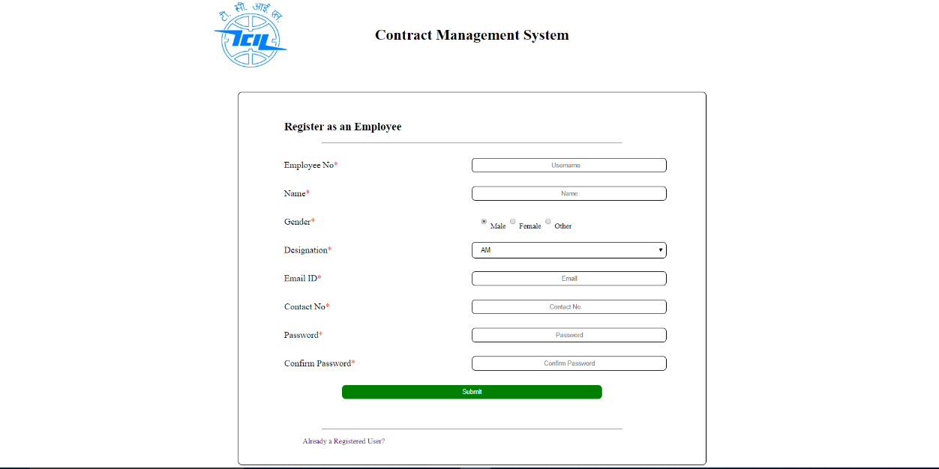

***Figure 1.1:*** *Register page of the ContractFlow*

*The Registration page inputs the details of the new employee on the system and enters the details into the Database.*

***Source:*** *vasharma05,*

*https://github.com/vasharma05 /Screenshots/Register.PNG*

**LOGIN PAGE:**

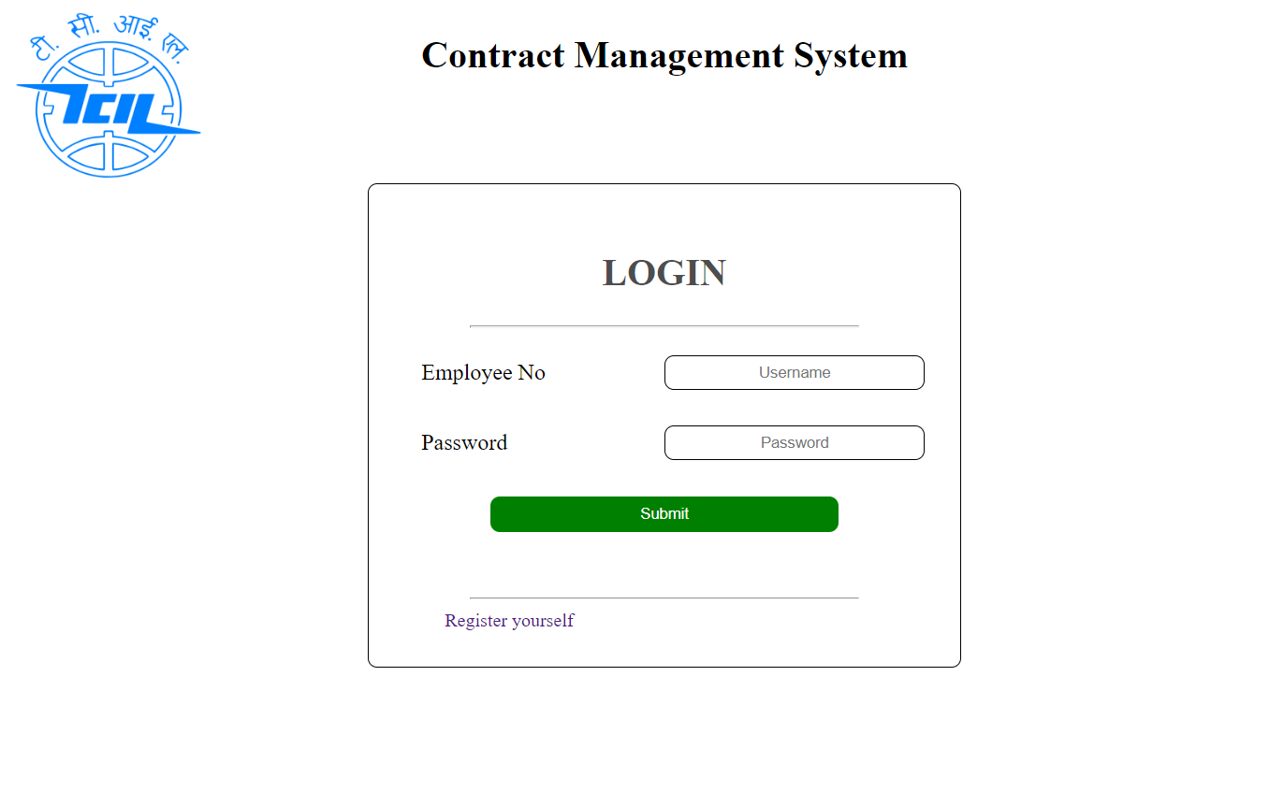

***Figure 1.2:*** *Login page of the ContractFlow*

*The Login Page/Home Page consists of 2 fields Employee ID, Password. On Failure, it will alert ‘No User Found’, else on success it will direct to the admin page, with Enabling the session_start() function and the Employee Name and Employee ID who logged in.*

***Source:*** *vasharma05,*

*https://github.com/vasharma05 /Screenshots/Login.PNG*

**ADD CLIENT SECTION:**

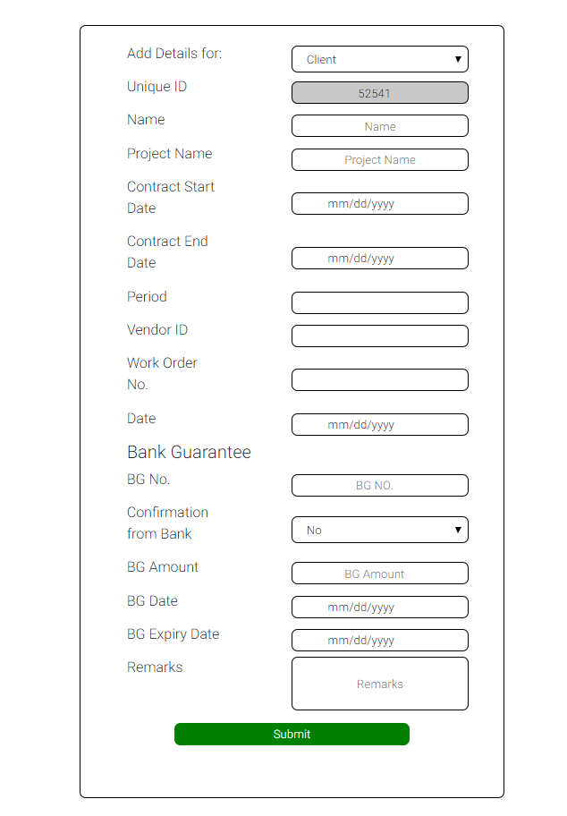

***Figure 1.3:*** *Add Client Section of the ContractFlow*

*Add Client Section This section will slide down when “Add Vendors” button is clicked and will show a form wherein the admin can enter the Details of the new Client.*

***Source:*** *vasharma05,*

*https://github.com/vasharma05 /Screenshots/Add%20Clients.PNG*

**EDIT/UPDATE SECTION:**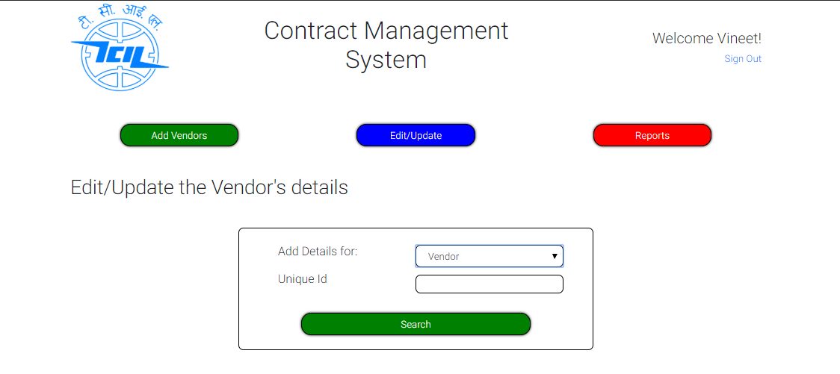

***Figure 1.5:*** *EDIT/UPDATE SECTION of the ContractFlow*

*EDIT/UPDATE SECTION In this section first the admin will select whose details are to be Updated and will select from the select box. After selecting one of these and entering the Unique ID he/she can view their current details and can edit the field he/she wants to update.*

***Source:*** *vasharma05,*

*https://github.com/vasharma05 /Screenshots/Edit%20Vendor.PNG*

**SITE FEATURES**

**Register Page:**

The Register Page features a user-friendly form for new employee registration with validation checks to ensure accurate data input. It securely stores employee details in the database.

**Login Page:**

The Login Page includes a login interface with Employee ID and Password fields, error handling for failed login attempts, and successful login redirection to the admin page. It utilizes PHP's **session_start()** to maintain user sessions and displays the logged-in Employee's Name and ID on the admin page.

**Admin Page:**

The Admin Page offers a personalized welcome message displaying the user's name, a default view of the Reports Section listing Clients and Vendors, and access to the Add Client and Add Vendor sections. It also provides access to the Edit/Update Section for modifying client/vendor details.

**Add Client Section:**

The Add Client Section features an "Add Client" button that reveals the client details form, with validation checks for data accuracy.

**Edit/Update Section:**

The Edit/Update Section includes a dropdown to select the client/vendor for updating, an input field for entering the Unique ID, and the display of current details for the selected client/vendor. It allows users to edit specific fields for updating.

**Additional Features:**

* In the Reports Section, contract end date-based background color changes:
  + Contracts ending in more than 15 days turn orange.
  + Contracts ending in 15 days or less turn red.
  + Automatic email notifications to clients/vendors for contracts ending in 15 days or less.

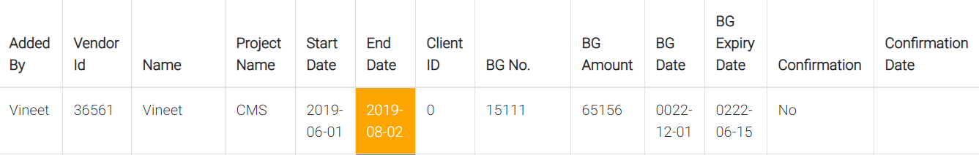

***Figure 1.6:*** *Report Section of the ContractFlow*

***Source:*** *vasharma05,*

*https://github.com/vasharma05 /Screenshots/* *Orange.PNG*

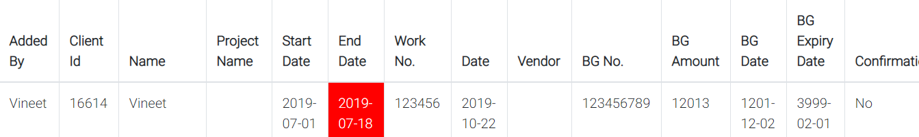

***Figure 1.7:*** *Report Section of the ContractFlow*

***Source:*** *vasharma05,*

*https://github.com/vasharma05 /Screenshots/* *Red.PNG*

* Unique ID generation for clients/vendors with a random 5-digit number.
* Period calculation in the Add Client/Vendor Section for showing the difference between the Start Date and End Date.
* Dynamic field visibility based on the selection of Client/Vendor or Vendor/Client.
* Conditional display of Confirmation Date based on the choice of "Yes" or "No" for Confirmation from Bank.

**DEVELOPMENT PROCESS**

**Phase 1 – Orientation and Development of Strategic Concept**

**Confirm and Refine Objectives:** In this phase, we will meticulously confirm and refine the objectives of the ContractFlow system based on insights and findings gathered during the initial study. The key activities include:

* Reviewing and validating the initial objectives to ensure they meet the SMART criteria (Specific, Measurable, Achievable, Relevant, and Time-bound).
* Carefully refining the objectives to closely align them with the identified needs and opportunities within contract management.
* Engaging in collaborative discussions with stakeholders to gather their input and insights, ensuring that the objectives are a true reflection of their expectations.

**Confirm and Refine Target Market**: Understanding our target market is paramount for the success of the ContractFlow system. During this phase, we will:

* Thoroughly validate and refine our understanding of the target market based on the comprehensive data collected in the orientation phase.
* Identify specific segments within the target market and delve into their unique needs.
* Analyze the demographics, preferences, and behaviors of our target audience.
* Use this refined understanding to inform decisions regarding user experience design, feature prioritization, and communication strategies.

**Establish Success Criteria:** Determining how we will measure the success of the ContractFlow system is a vital step to keep the project on track and evaluate its impact. In this phase, we will:

* Define clear and quantifiable success criteria, such as increased contract compliance, minimized risk, and improved efficiency.
* Set specific benchmarks and key performance indicators (KPIs) that will be used to assess the project's success.
* Ensure that these success criteria align seamlessly with the project objectives, leaving no room for ambiguity.

**Establish a Preliminary Site and Page Hierarchy**: Creating a preliminary site and page hierarchy is essential to structure the information and navigation within the ContractFlow system. In this phase, we will:

* Develop a preliminary sitemap that outlines the primary sections, pages, and their hierarchical relationships.
* Consider the user journey, ensuring that users can navigate the system intuitively.
* Maintain flexibility in the site and page hierarchy to accommodate any changes as the project evolves.

**Develop One or More Graphic Options:** Visual design plays a pivotal role in engaging users and enhancing their experience. In this phase, we will:

* Initiate the graphic design process by crafting one or more design concepts or mockups for the ContractFlow system's user interface.
* Seamlessly incorporate branding elements, including colors, typography, and visual style, aligning them with the project's objectives and appealing to our target audience.
* Ensure that the design options prioritize accessibility and usability principles, guaranteeing an inclusive and user-friendly design.

**Present Options for Evaluation:** To make informed decisions and involve stakeholders in the design process, we will:

* Present the refined objectives, target market analysis, success criteria, and graphic design options to stakeholders.
* Actively collect feedback and input from stakeholders to make necessary adjustments, fostering a collaborative approach to define the strategic direction of the ContractFlow project.

**Estimated Time:** 2 to 3 weeks

**Phase 2 – Concept Approval and Initial Development**

**Incorporation of Feedback and Revisions**: Building upon the insights gained in Phase 1, we will focus on incorporating feedback and revisions to refine the ContractFlow system concept. This phase encompasses the following key elements:

* Thoroughly reviewing all feedback collected from stakeholders during Phase 1, including their input on objectives, target market, success criteria, and graphic options.
* Analyzing the feedback to identify common themes, concerns, and areas for improvement.
* Developing a comprehensive revision plan that outlines how feedback will be integrated into the project.
* Prioritizing feedback based on its impact on project objectives and alignment with the strategic concept.
* Ensuring that all objectives remain precise and aligned with the project's overall goals.
* Further refining our understanding of the target market based on stakeholder feedback, addressing any misconceptions or gaps.
* Adjusting success criteria to reflect changes in project objectives or stakeholder priorities.

**Develop Site Artwork:** The development of site artwork is a critical step in bringing the ContractFlow system to life. During this phase, we will:

* Execute the full-scale development of site artwork based on the approved design concept from Phase 1 and feedback received.
* Create visual elements, including icons, images, layouts, and user interface components.
* Pay meticulous attention to the user interface (UI) design, ensuring it aligns with the project's goals, target market preferences, and stakeholder feedback.
* Emphasize usability, accessibility, and responsive design to provide a seamless user experience.

**Present Artwork for Approval:** To ensure alignment with the project's strategic concept and objectives, we will:

* Prepare a comprehensive presentation that showcases the developed site artwork, including design mockups, user interfaces, and visual elements.
* Invite stakeholders, including project sponsors, key healthcare professionals, and potential end-users, to review and evaluate the presented artwork.
* Provide stakeholders with the opportunity to ask questions, express concerns, and offer further suggestions.
* Actively listen to stakeholder feedback during the presentation.
* Document any additional feedback or revisions requested by stakeholders.
* Seek formal approval for the site artwork from relevant stakeholders, ensuring that all concerns are addressed and that the final artwork aligns seamlessly with the project's strategic direction.

**Estimated Time:** The duration of Phase 2 may vary depending on the complexity of the design and the availability of other technical resources, ranging from 5 to 7 days.

**Phase 3 – Revisions and Final Development (Time Frame: Approximately 4 to 6 weeks)**

**Incorporate Artwork Feedbacks and Revisions:** This phase involves the incorporation of feedback and revisions gathered during the artwork presentation in Phase 2 to further enhance the ContractFlow system. Key aspects include:

**Feedback Consolidation:**

* Review and consolidate any additional feedback received during the artwork presentation in Phase 2.
* Categorize feedback into actionable items for implementation.

**Revision Implementation:**

* Collaborate closely with the design and development teams to implement the necessary revisions and adjustments to the site artwork.
* Ensure that all stakeholders' concerns and suggestions are addressed effectively.

**Finalize Illustrations and Photography:** As we move towards the final development phase, it's essential to ensure that all visual elements are polished and aligned with the project's objectives. This includes:

**Illustrations and Photography Selection:**

* Finalize the selection of illustrations and photographs that will be integrated into the ContractFlow system.
* Ensure that the chosen visuals align with the approved artwork and meet quality standards.

**Acquisition and Licensing:**

* Acquire necessary licenses or permissions for using illustrations and photographs, ensuring compliance with copyright and usage rights.

**Online Preview:** To ensure that the ContractFlow system is ready for the final stages of development, we will:

**Preview Preparation:**

* Compile the revised site artwork, illustrations, and photographs into an online preview version of the system.
* Ensure that all visual elements are properly integrated and functional.

**Stakeholder Preview:**

* Share the online preview with stakeholders for a final review before proceeding to the next phase.
* Provide stakeholders with access to the preview and gather their feedback.

**Revise Site if Necessary**: Based on feedback received during the online preview phase, we will:

**Feedback Review:**

* Analyze the feedback gathered during the online preview phase.
* Identify any necessary revisions or adjustments to the site's design and functionality.

**Revision Implementation:**

* Collaborate with the development team to implement the final round of revisions based on stakeholder feedback.
* Ensure that the site meets usability, accessibility, and performance standards.

**Installation and Testing:** As we approach the final stages of development, it's crucial to ensure that the ContractFlow system is robust and functional:

**System Installation:**

* Install the finalized system on the designated servers or hosting environment.
* Ensure all necessary configurations are in place.

**Testing Phase:**

* Conduct comprehensive testing, including functional, usability, security, and performance testing.
* Identify and address any bugs, issues, or discrepancies.
* Ensure compatibility with various browsers and devices.

Go Live (Date to Be Determined): The actual go-live date should be determined based on the completion of all preceding tasks, successful testing, and stakeholder approval:

**Go-Live Planning:**

* Plan for the official launch of the ContractFlow system, considering factors like user communication, data migration (if applicable), and server readiness.

**Stakeholder Notification:**

* Notify stakeholders, including project sponsors, users, and administrators, about the impending launch date and any relevant instructions or changes.

**Deployment:**

* Execute the final deployment of the ContractFlow system to the production environment on the determined go-live date.

**Monitoring and Support:**

* Monitor the system closely after the go-live to address any immediate issues or concerns.
* Provide ongoing support and maintenance to ensure smooth operation.

**Estimated Time**: The estimated duration for Phase 3 is approximately 1 to 2 days, depending on the type of revisions gathered from the online testing and recommendations.

**Cost Analysis**

|  |  |  |  |
| --- | --- | --- | --- |
| Development Cost | Phase 1 | | PHP 200,000 - 300,000 |
| Phase 2 | | PHP 50,000 - 70,000 |
| Phase 3 | | PHP 300,000 - 500,000 |
| Design and artwork cost | Phase 1 | | PHP 30,000 - 50,000 |
| Phase 2 | | PHP 10,000 - 15,000 |
| Phase 3 | | PHP 50,000 - 80,000 |
| Data Acquisition and Integration Costs | Phase 1 | | PHP 20,000 - 40,000 |
| Phase 2 | | PHP 10,000 - 20,000 |
| Testing and Quality Assurance Costs | Phase 3 | | PHP 30,000 - 50,000 |
| Infrastructure and Hosting Costs | Phase 3 | | PHP 10,000 - 20,000 |
| Domain Name Registration | One-time cost for domain registration | | PHP 1,000 - 2,000 |
| Additional Expenses | Contingency budget (10% of the total estimated cost) | | Approximately PHP 90,000 - 150,000 |
| Maintenance and Support Costs | PHP 50,000 to PHP 150,000 per year. | | |
| Estimated Total Cost | **PHP 491,000 to PHP 1,047,000 or more** | | |
|  | | ***Note:*** *Other payments include the renewal of the domain name and hosting services for the succeeding years. Additionally, updates and maintenance will be provided free of charge for the first year of operation* | |

**Working Agreement for Estimates - ContractFlow Development**

This working agreement governs the estimated costs and ownership arrangements for the ContractFlow development project. The provided cost estimates are preliminary and subject to adjustments based on project-specific requirements, scope modifications, and scheduling changes. These estimates encompass various project phases, including meetings, consultations, design, production, and a reasonable number of revisions.

Significant additional services and potential delays that may arise during the project will be addressed as necessary, with updated cost estimates provided upon approval of any final design direction changes. Regarding ownership, this proposal relates to the development and implementation of a single strategic concept. All intellectual property, including concepts, ideas, plans, designs, artwork, and electronic files, generated during the project will remain the exclusive property of our development group, with the discretion to utilize these materials in the future.

Ownership of project materials, including original artwork, computer-generated content, formats, and electronic code, will also reside with the development group unless otherwise stipulated in writing. Furthermore, copyright for the ContractFlow website design will be transferred to the project owner upon receipt of full payment, accompanied by the granting of reproduction rights to meet the project owner's future needs. This working agreement lays the foundation for development and ownership aspects, with detailed contractual terms and conditions to be provided in a formal project agreement, ensuring transparency and legal compliance throughout the project's lifecycle**.**